**Introduction to IOT**

**LAB ACTIVITY –** **2**

**Institute of Engineering and Technology**

**JK Lakshmipat University, Jaipur**

**SUBMITTED TO**

Mr. Divanshu Jain

**SUBMITTED BY**

Garv Baheti

2020BTechCSE031

**August 29, 2022**

**OBJECTIVE**

1. To blink LED when the intensity of room changes using LDR
2. To turn on a buzzer/LED when an object is detected using IR sensor in analog mode.
3. To turn on a buzzer/LED when an object is detected using IR sensor in digital mode.
4. Calculate the distance of an object using Ultrasonic Sensor and control a led and show the value on serial monitor.

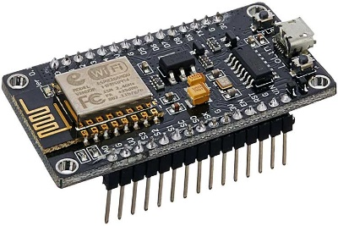**THEORY**

NodeMCU is an open-source Lua based firmware and development board specially targeted for IoT based Applications. It includes firmware that runs on the ESP8266 Wi-Fi SoC from Espressif Systems, and hardware which is based on the ESP-12 module. The **NodeMCU ESP8266 development board** comes with the ESP-12E module containing the ESP8266 chip having Tensilica Xtensa 32-bit LX106 RISC microprocessor. This microprocessor supports RTOS and operates at 80MHz to 160 MHz adjustable clock frequency. NodeMCU has 128 KB RAM and 4MB of Flash memory to store data and programs. Its high processing power with in-built Wi-Fi / Bluetooth and Deep Sleep Operating features make it ideal for IoT projects. NodeMCU can be powered using a Micro USB jack and VIN pin (External Supply Pin). It supports UART, SPI, and I2C interface.

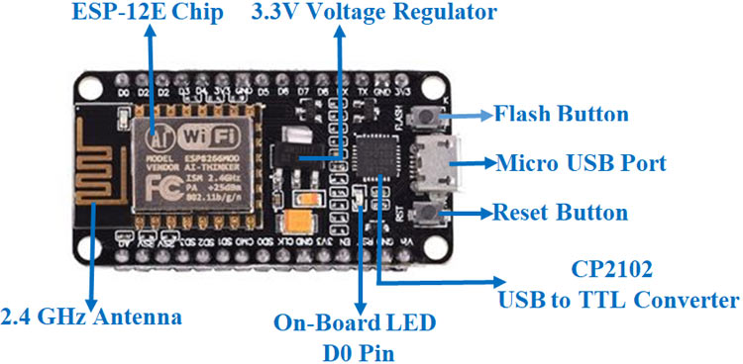

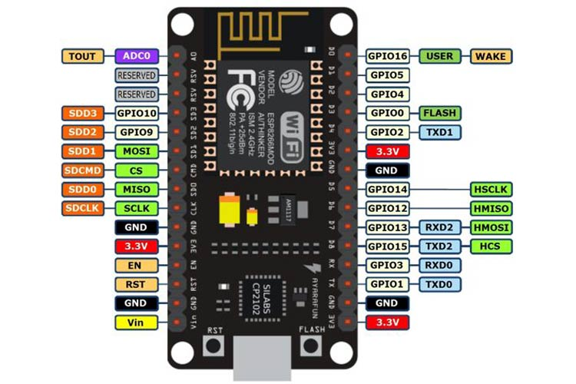

**NodeMCU ESP8266 Specifications & Features**

* Microcontroller: Tensilica 32-bit RISC CPU Xtensa LX106
* Operating Voltage: 3.3V
* Input Voltage: 7-12V
* Digital I/O Pins (DIO): 16
* Analog Input Pins (ADC): 1
* UARTs: 1
* SPIs: 1
* I2Cs: 1
* Flash Memory: 4 MB
* SRAM: 64 KB
* Clock Speed: 80 MHz
* USB-TTL based on CP2102 is included onboard, Enabling Plug n Play
* PCB Antenna
* Small Sized module to fit smartly inside your IoT projects

**NodeMCU Development Board Pinout Configuration**

|  |  |  |
| --- | --- | --- |
| **Pin Category** | **Name** | **Description** |
| Power | Micro-USB, 3.3V, GND, Vin | **Micro-USB:** NodeMCU can be powered through the USB port  **3.3V:** Regulated 3.3V can be supplied to this pin to power the board  **GND:** Ground pins  **Vin:**External Power Supply |
| Control Pins | **EN, RST** | The pin and the button resets the microcontroller |
| Analog Pin | A0 | Used to measure analog voltage in the range of 0-3.3V |
| GPIO Pins | GPIO1 to GPIO16 | NodeMCU has 16 general purpose input-output pins on its board |
| SPI Pins | SD1, CMD, SD0, CLK | NodeMCU has four pins available for SPI communication. |
| UART Pins | TXD0, RXD0, TXD2, RXD2 | NodeMCU has two UART interfaces, UART0 (RXD0 & TXD0) and UART1 (RXD1 & TXD1). UART1 is used to upload the firmware/program. |
| I2C Pins |  | NodeMCU has I2C functionality support but due to the internal functionality of these pins, you have to find which pin is I2C. |

**TO BLINK LED WHEN THE INTENSITY OF ROOM CHANGES USING LDR**

**REQUIREMENTS**

* NodeMCU x 1
* Micro USB cable x 1
* PC x 1
* Software Arduino IDE(version 1.6.4+)
* LDR Sensor
* LED
* Resistor

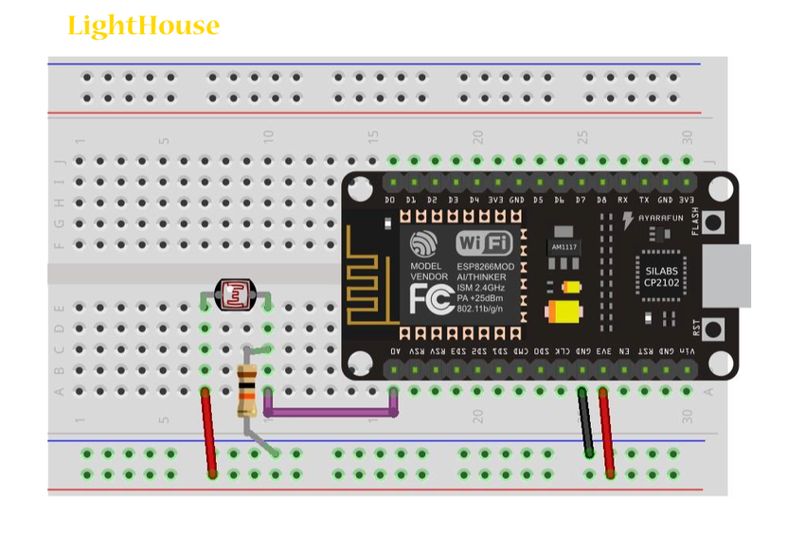 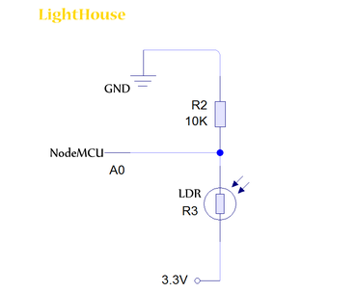

**CODE**

const int ledPin = 5;

const int ldrPin = A0;

void setup() {

Serial.begin(9600);

pinMode(ledPin, OUTPUT);

pinMode(ldrPin, INPUT);

}

void loop() {

int ldrStatus = analogRead(ldrPin);

Serial.print(ldrStatus);

if (ldrStatus <=300) {

digitalWrite(ledPin, HIGH);

Serial.println("LDR is DARK, LED is ON");

}

else {

digitalWrite(ledPin, LOW);

Serial.println("LED is OFF");

}

}

**RESULT**

When No Light is detected

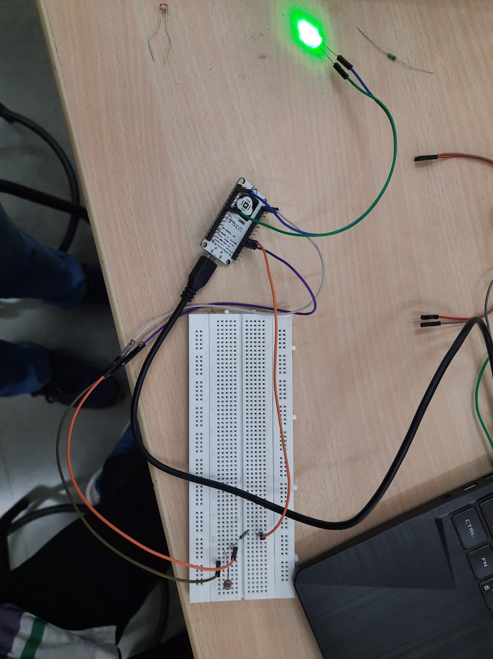

When Light is detected

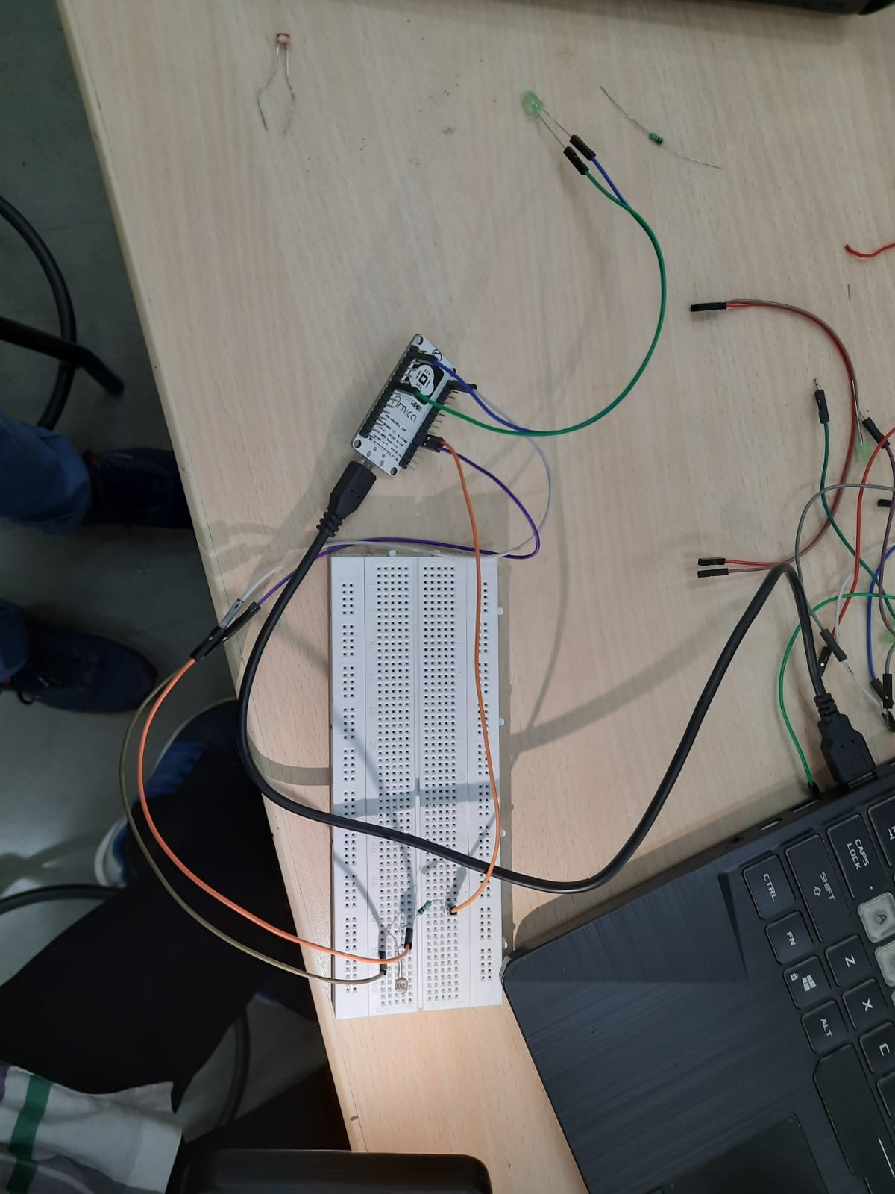

**TO TURN ON A BUZZER/LED WHEN AN OBJECT IS DETECTED USING IR SENSOR IN ANALOG MODE.**

**REQUIREMENTS**

* NodeMCU x 1
* Micro USB cable x 1
* PC x 1
* Software Arduino IDE (version 1.6.4+)
* LED
* IR SENSOR

**CIRCUIT**

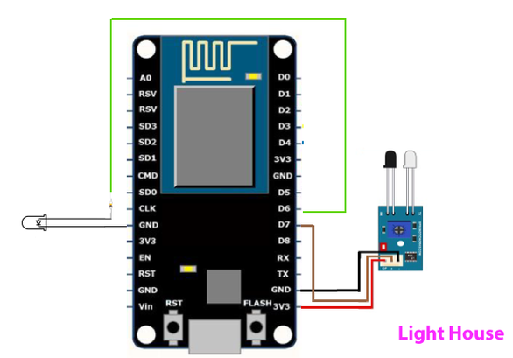

**CODE**

int ledPin = 12; // choose pin for the LED

int inputPin = A0; // choose input pin (for Infrared sensor)

int val = 0; // variable for reading the pin status

void setup()

{

pinMode(ledPin, OUTPUT); // declare LED as output

pinMode(inputPin, INPUT); // declare Infrared sensor as input

Serial.begin(9600);

}

void loop()

{

val = analogRead(inputPin); // read input value

if (val >=700)

{ // check if the input is HIGH

digitalWrite(ledPin, HIGH); // turn LED ON

Serial.println("OBJECT DETECTED");

Serial.println(val);

}

else

{

digitalWrite(ledPin, LOW); // turn LED OFF

Serial.println("NO OBJECT DETECTED");

Serial.println(val);

}

}

**RESULT**

When Object is Detected(<15cm)

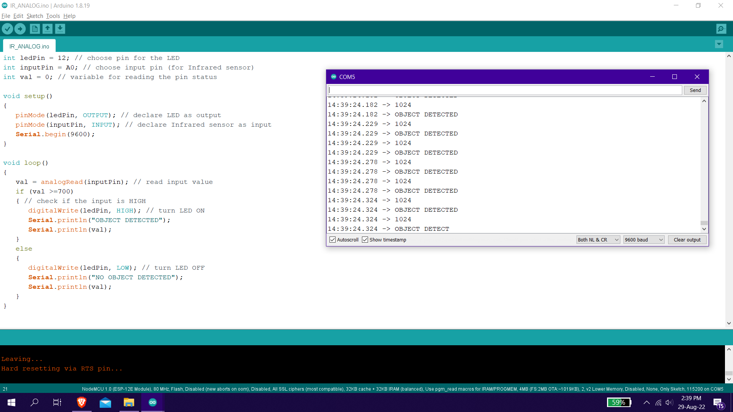

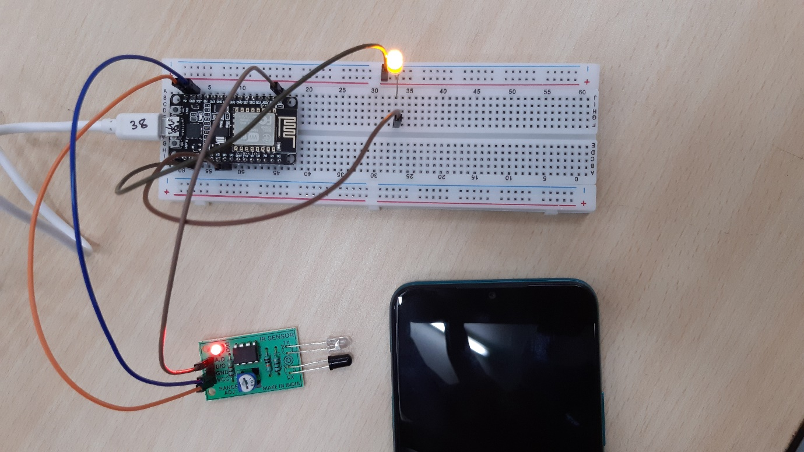

When Object is Not Detected(>15cm)

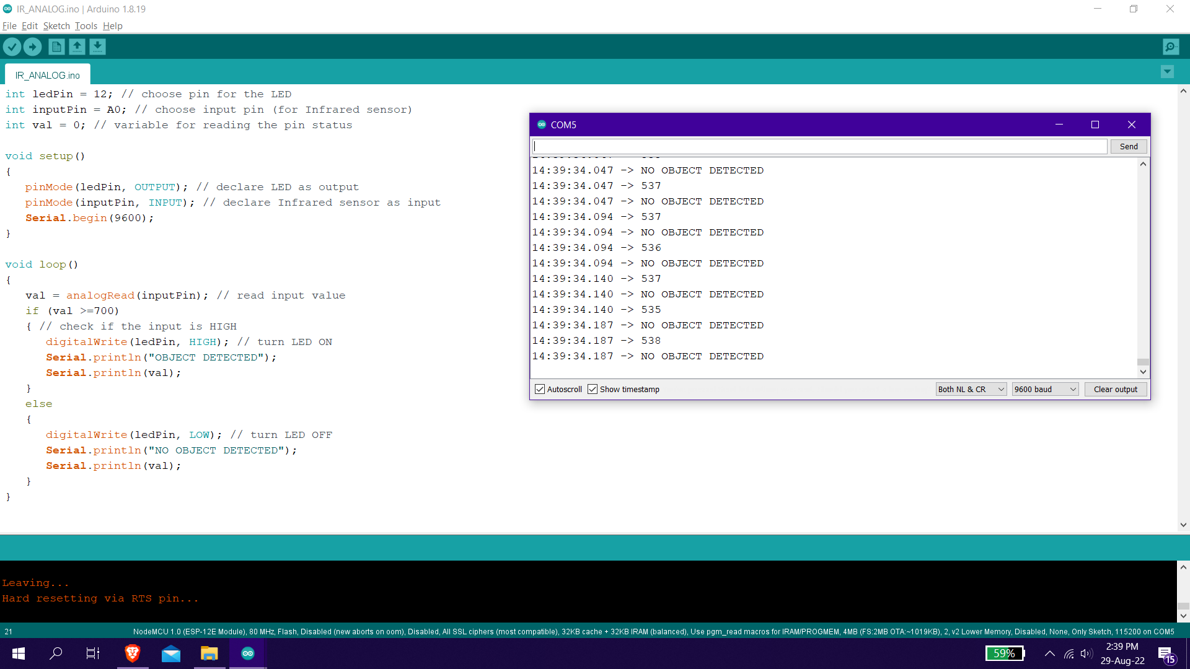

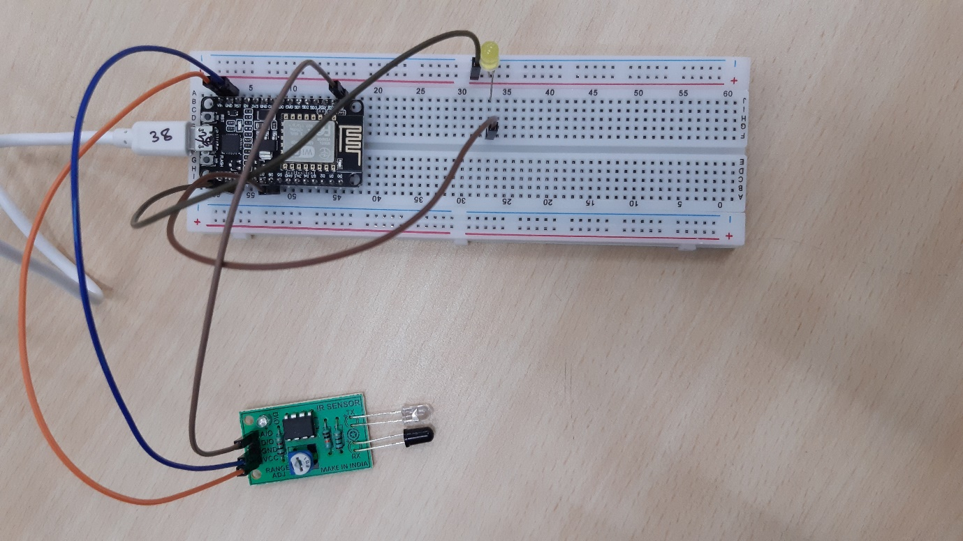

When Object is not close enough

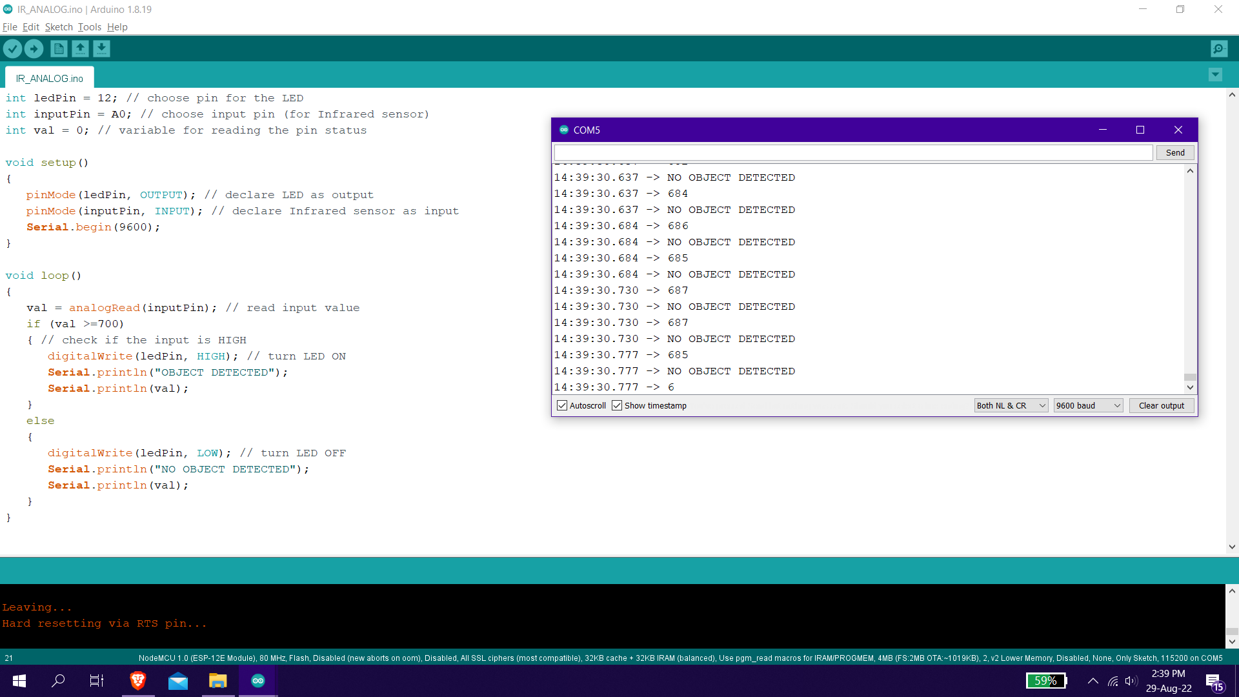

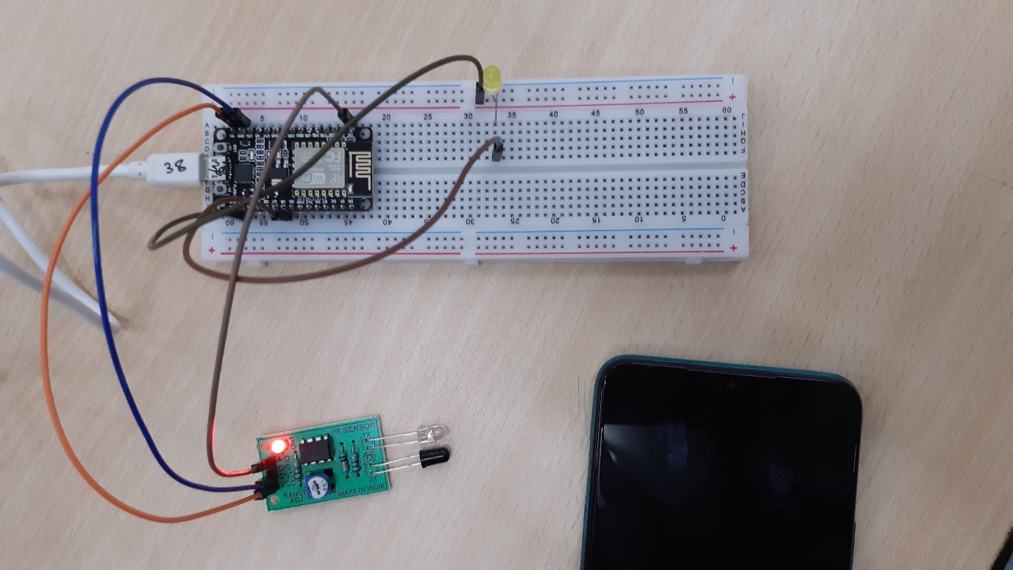

**TO TURN ON A BUZZER/LED WHEN AN OBJECT IS DETECTED USING IR SENSOR IN DIGITAL MODE.**

**REQUIREMENTS**

* NodeMCU x 1
* Micro USB cable x 1
* PC x 1
* Software Arduino IDE(version 1.6.4+)
* IR SENSOR
* LED

**CODE**

int ledPin = 12; // choose pin for the LED

int inputPin = 13; // choose input pin (for Infrared sensor)

int val = 0; // variable for reading the pin status

void setup()

{

pinMode(ledPin, OUTPUT); // declare LED as output

pinMode(inputPin, INPUT); // declare Infrared sensor as input

Serial.begin(9600);

}

void loop()

{

val = digitalRead(inputPin); // read input value

if (val == HIGH)

{ // check if the input is HIGH

digitalWrite(ledPin, HIGH); // turn LED ON

Serial.println("OBJECT DETECTED");

}

else

{

digitalWrite(ledPin, LOW); // turn LED OFF

Serial.println("NO OBJECT DETECTED");

}

}

**RESULT**

When No Object is detected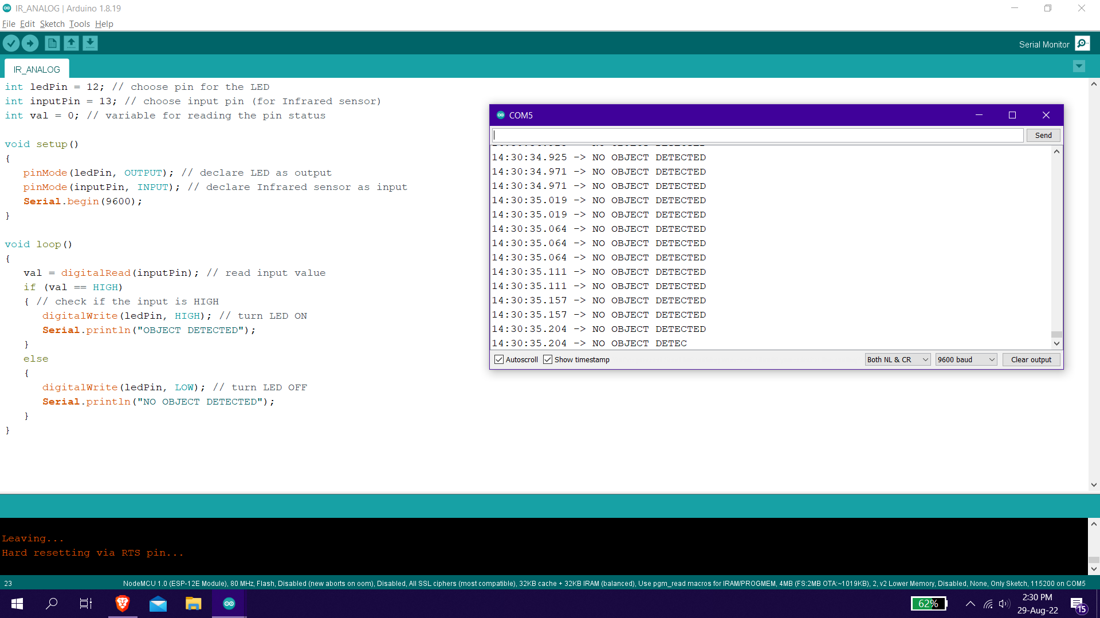

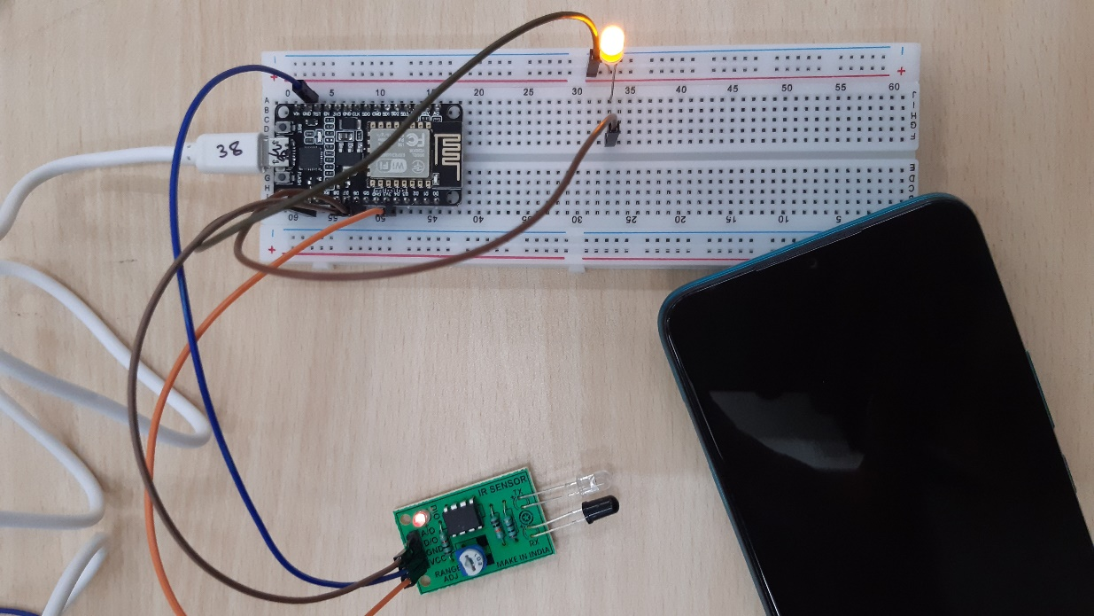

When Object is Not detected

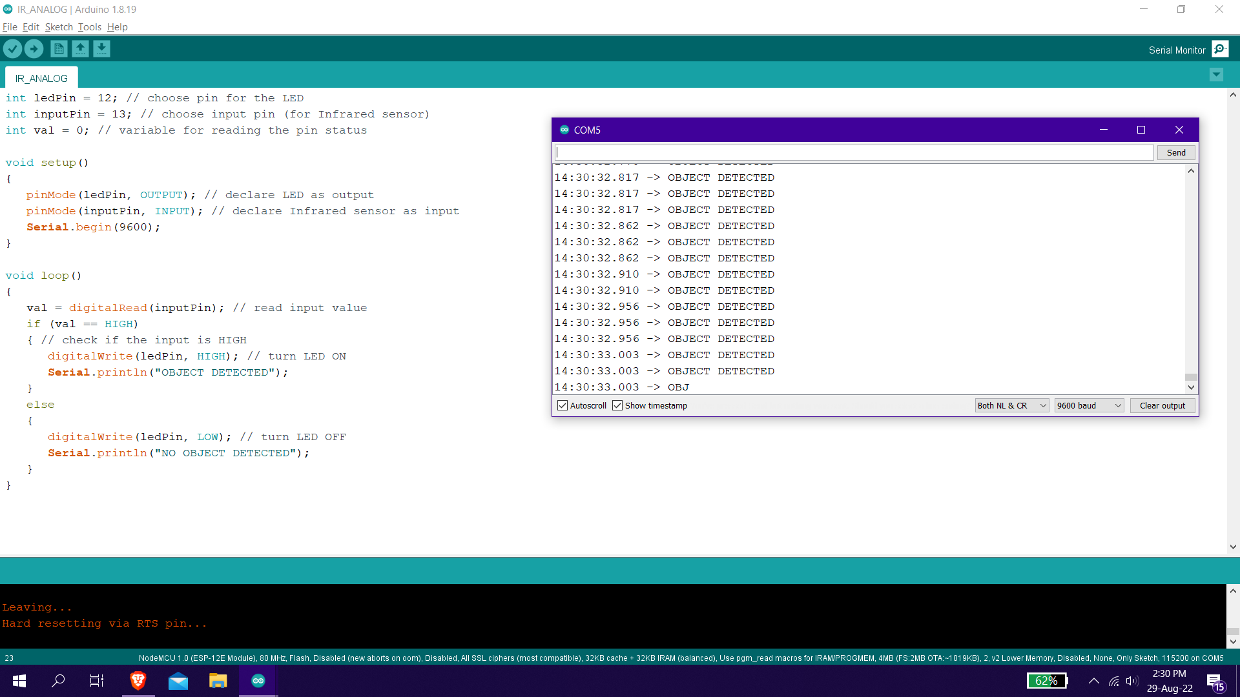

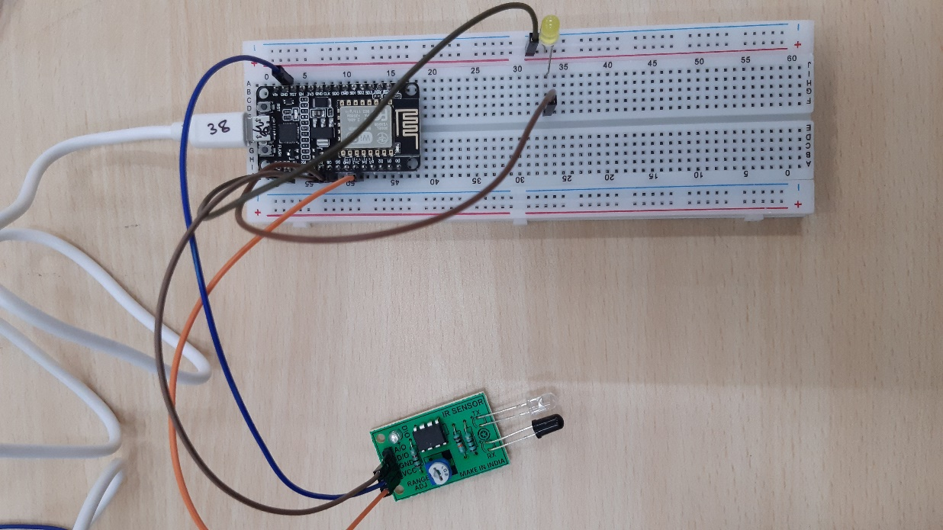

**CALCULATE THE DISTANCE OF AN OBJECT USING ULTRASONIC SENSOR AND CONTROL A LED AND SHOW THE VALUE ON SERIAL MONITOR**

**REQUIREMENTS**

* NodeMCU x 1
* Micro USB cable x 1
* PC x 1
* Software Arduino IDE (version 1.6.4+)
* Ultrasonic Sensor
* LED

**CIRCUIT**

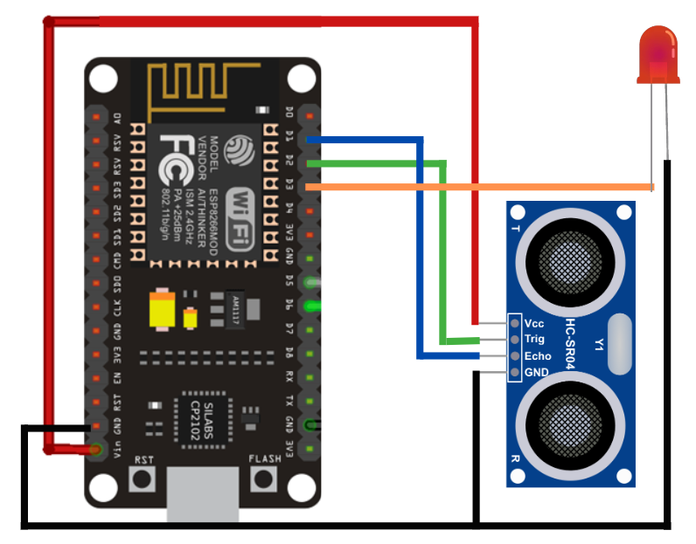

**CODE**

int trigPin=D2;

int echoPin=D1;

int led = D3;

#define SOUND_VELOCITY 0.034

long duration;

float distanceCm;

void setup() {

// put your setup code here, to run once:

Serial.begin(9600); // Starts the serial communication

pinMode(trigPin, OUTPUT); // Sets the trigPin as an Output

pinMode(echoPin, INPUT); // Sets the echoPin as an Input

pinMode(led,OUTPUT);

}

void loop() {

// put your main code here, to run repeatedly:

digitalWrite(trigPin, LOW);

delay(200);

// Sets the trigPin on HIGH state for 10 micro seconds

digitalWrite(trigPin, HIGH);

delay(100);

digitalWrite(trigPin, LOW);

// Reads the echoPin, returns the sound wave travel time in microseconds

duration = pulseIn(echoPin, HIGH);

// Calculate the distance

distanceCm = duration * SOUND_VELOCITY/2;

if(distanceCm<=15){

digitalWrite(led,HIGH);

delay(100);

}

else{

digitalWrite(led,LOW);

delay(100);

}

// Prints the distance on the Serial Monitor

Serial.print("Distance (cm): ");

Serial.println(distanceCm);

delay(1000);

}

**RESULT**

